CUSTOMER SEGMENTATION ANALYSIS USING RFM MODEL

Title: Customer Segmentation Analysis
Prepared By: Rupjit Das
Tools Used: Python, Pandas, NumPy, Matplotlib, Seaborn
Dataset: DataCo Supply Chain Dataset

Executive Summary
This project applies the RFM (Recency, Frequency, Monetary) framework to analyze customer purchasing behavior and segment customers based on their value to the business.
The analysis evaluates how recently customers purchased, how frequently they place orders, and how much revenue they generate. Using these metrics, customers were classified into distinct segments including Champions, Loyal Customers, Potential Loyalists, At Risk Customers, and Lost Customers.
The results provide valuable insights into customer engagement, retention opportunities, and revenue concentration, enabling organizations to design targeted marketing and customer retention strategies.

Business Problem
Customer behavior varies significantly across a business. While some customers purchase frequently and generate substantial revenue, others become inactive or contribute minimal value.
Without proper customer segmentation, organizations may struggle to identify high-value customers, retain loyal customers, and re-engage customers at risk of churn.
A structured customer segmentation framework is required to better understand customer value and support data-driven marketing decisions.

Project Objectives
The objectives of this project are:
• Analyze customer purchasing behavior using RFM metrics.
• Measure customer Recency, Frequency, and Monetary value.
• Segment customers based on purchasing patterns.
• Identify high-value and at-risk customers.
• Evaluate revenue contribution across customer segments.
• Generate actionable recommendations for customer retention and growth.

Dataset Overview

Dataset Name: DataCo Supply Chain Dataset

Total Customers: 20,652

Analysis Scope: Customer Segmentation Analysis

Key Variables
• Customer Id
• Order Id
• Sales
• order date (DateOrders)

Derived Variables
• Recency
• Frequency
• Monetary
• R Score
• F Score
• M Score
• RFM Total Score
• Customer Segment

Executive KPI Dashboard
1781.17
Average Monetary Value
3.18
Average Frequency
221
Average Recency
20,652
Total Customers

Interpretation
The KPI dashboard provides a high-level overview of customer behavior and purchasing activity. These metrics help management understand customer engagement and overall customer value.

RFM Metric Distributions (Recency, Frequency & Monetary)
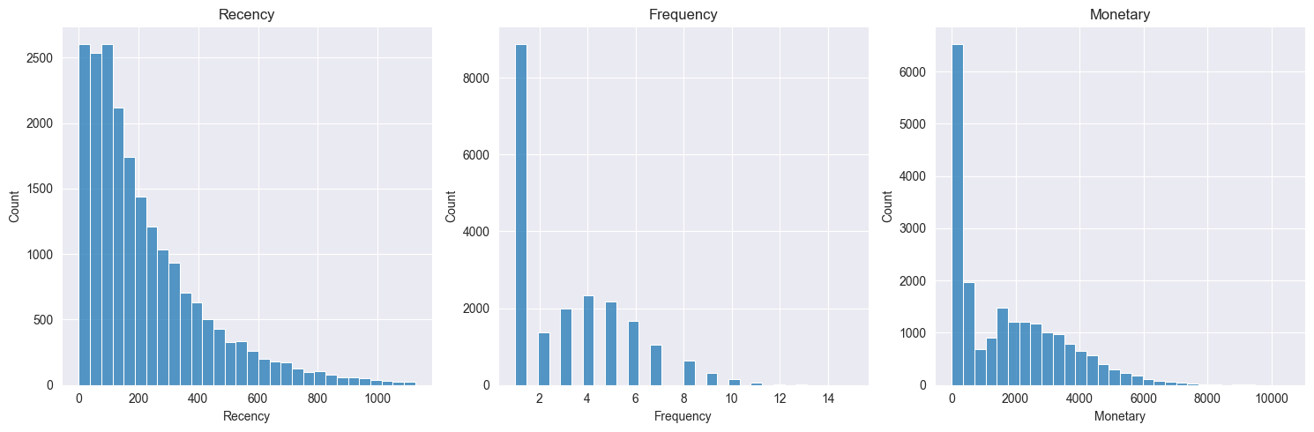
1. Recency Distribution
Observation
- The Recency distribution is heavily right-skewed.
- Most customers have low Recency values, indicating relatively recent purchases.
- The number of customers gradually decreases as Recency increases.
- A small group of customers has very high Recency values (800–1100 days).
Interpretation
Most customers have interacted with the business recently, while a smaller portion has remained inactive for long periods. The long tail indicates the presence of dormant customers who have not made purchases in a significant amount of time.
Business Impact
A large active customer base is a positive sign for customer retention. However, customers with very high Recency values may be at risk of churn and represent potential lost revenue.
Recommendation
Implement re-engagement campaigns for customers with high Recency values through personalized offers, email marketing, and targeted promotions.

2. Frequency Distribution
Observation
- The distribution is highly concentrated around Frequency = 1.
- Customer count decreases steadily as purchase frequency increases.
- Only a small number of customers place more than 8–10 orders.
Interpretation
Most customers are one-time or occasional buyers, while a relatively small group of customers generates repeat purchases.
Business Impact
The business depends heavily on converting first-time buyers into repeat customers. Increasing customer purchase frequency can significantly improve customer lifetime value and revenue stability.
Recommendation
Develop loyalty programs, membership benefits, and personalized recommendations to encourage repeat purchases and improve customer retention.

3. Monetary Distribution
Observation
- The Monetary distribution is strongly right-skewed.
- Most customers generate relatively low revenue.
- A small number of customers contribute exceptionally high spending, reaching over 10,000 in revenue.
Interpretation
Customer spending is unevenly distributed, with a small group of high-value customers generating a disproportionate share of total revenue.
Business Impact
The business relies on a relatively small segment of high-spending customers. Losing these customers could have a significant impact on revenue performance.
Recommendation
Identify and prioritize high-value customers through VIP programs, personalized engagement strategies, and premium customer support.

Customer Segment Distribution
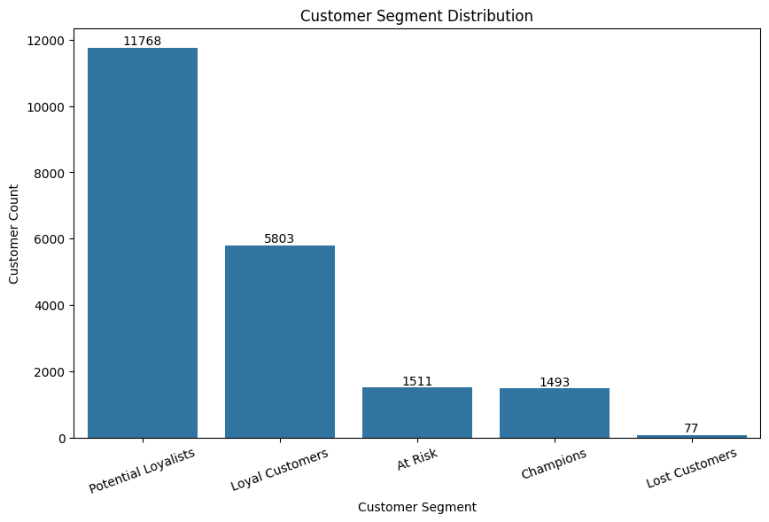
Observation
- Potential Loyalists form the largest customer segment with 11,768 customers, accounting for more than half of the customer base.
- Loyal Customers represent the second-largest segment with 5,803 customers.
- The business has 1,493 Champion customers, who represent the highest-value customer group.
- 1,511 customers are classified as At Risk.
- Only 77 customers belong to the Lost Customer segment.
Interpretation
The customer base is dominated by Potential Loyalists and Loyal Customers, indicating strong customer engagement and significant opportunities for customer growth. The presence of nearly 1,500 Champions demonstrates that the business has a solid foundation of highly valuable customers. The very small Lost Customer segment suggests effective customer retention.
Business Impact
A large proportion of customers are already showing positive purchasing behavior and can potentially be converted into higher-value segments. Improving engagement among Potential Loyalists could significantly increase customer lifetime value and overall revenue. Additionally, retaining Champion customers is crucial as they contribute disproportionately to business performance.
Recommendation
- Implement loyalty programs to convert Potential Loyalists into Loyal Customers and Champions.
- Provide exclusive rewards and personalized offers for Champion customers.
- Launch targeted retention campaigns for At Risk customers before they become inactive.
- Continue monitoring customer behavior to identify movement between segments.

Revenue Contribution by Segment
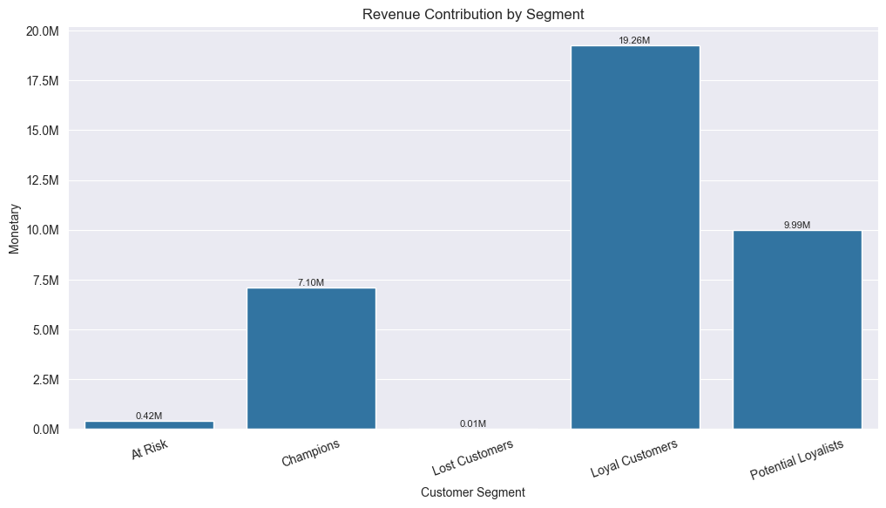
Observation
- Loyal Customers generate the highest revenue, contributing approximately 19.26M.
- Potential Loyalists contribute the second-highest revenue at approximately 9.99M.
- Champions contribute around 7.10M despite representing a much smaller customer group.
- At Risk Customers contribute only 0.42M.
- Lost Customers contribute virtually no revenue.
Interpretation
Revenue generation is heavily concentrated among Loyal Customers, Potential Loyalists, and Champions. Although Champions represent only a small portion of customers, they contribute substantial revenue, demonstrating their high individual customer value. Potential Loyalists also contribute significantly due to their large customer base, highlighting their future revenue potential.
Business Impact
The majority of business revenue comes from customers who remain actively engaged with the company. Any decline in Loyal Customers or Champions could have a direct and significant impact on overall revenue performance. Additionally, converting Potential Loyalists into higher-value segments could unlock substantial additional revenue.
Recommendation
- Prioritize retention strategies for Loyal Customers and Champions.
- Develop loyalty and reward programs to encourage Potential Loyalists to become Loyal Customers.
- Create personalized marketing campaigns targeting high-value customers.
- Monitor At Risk customers and implement retention initiatives before they become inactive.

Recency vs Monetary Analysis
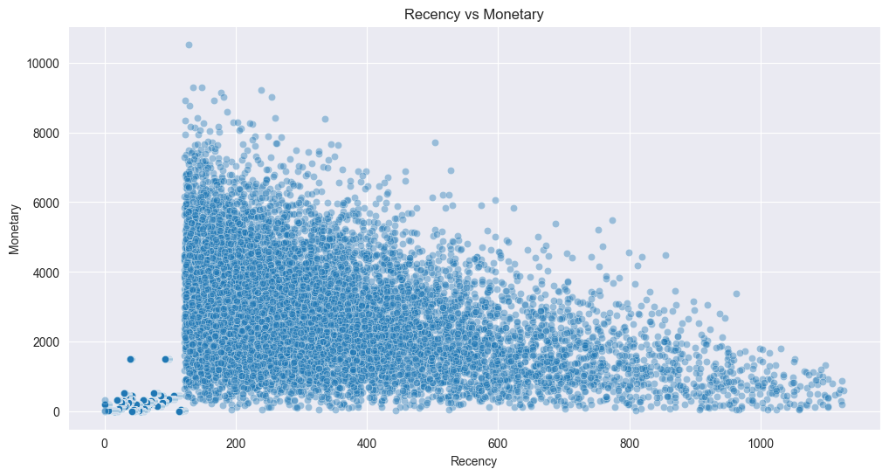
Observation
- The scatter plot shows a clear downward trend between Recency and Monetary value.
- Customers with lower Recency values (more recent purchases) tend to generate higher revenue.
- As Recency increases, the concentration of high-spending customers decreases significantly.
- Most customers with Recency above 800 days contribute relatively low revenue.
- A few high-value customers generate more than 8,000–10,000 in revenue, but these customers are concentrated among recently active customers.
Interpretation: The visualization indicates a negative relationship between Recency and Monetary value. Customers who have purchased recently are generally more valuable and contribute higher revenue, whereas customers who have not interacted with the business for a long time tend to spend less.
Business Impact: Customer inactivity directly affects revenue generation. As customers become less engaged over time, their spending declines, increasing the likelihood of churn and reducing overall customer lifetime value.
Recommendation
- Prioritize retention efforts for customers showing increasing Recency values.
- Implement reactivation campaigns for inactive customers before they become completely dormant.
- Maintain regular engagement with recent customers through personalized offers, loyalty rewards, and targeted marketing campaigns.
Frequency vs Monetary Analysis
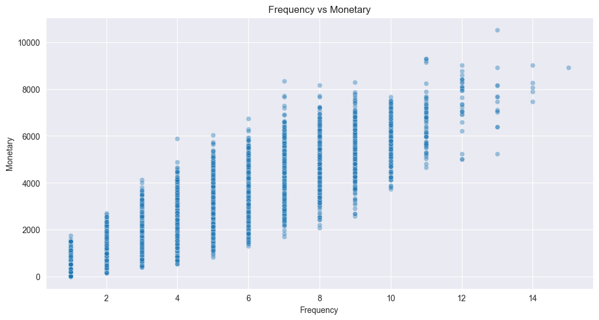
Observation
- The scatter plot shows a strong upward trend between Frequency and Monetary value.
- Customers with low purchase frequency (1–3 orders) generally contribute lower revenue.
- Monetary value consistently increases as Frequency increases.
- Customers with 10–15 purchases generate the highest revenue, often exceeding 6,000–10,000.
- High-frequency customers are relatively few in number but contribute significantly more revenue than occasional buyers.
Interpretation: The visualization indicates a strong positive relationship between Frequency and Monetary value. Customers who purchase more frequently tend to spend substantially more money, making them significantly more valuable to the business.
Business Impact: Repeat customers generate considerably higher revenue compared to one-time buyers. Increasing purchase frequency can directly improve customer lifetime value, customer retention, and overall business profitability.
Recommendation
- Implement loyalty and rewards programs to encourage repeat purchases.
- Use personalized product recommendations and targeted promotions to increase purchase frequency.
- Focus retention efforts on frequent buyers, as they contribute the highest revenue.
- Encourage occasional customers to become repeat customers through engagement campaigns and special offers.

Top 10 Customers by Revenue
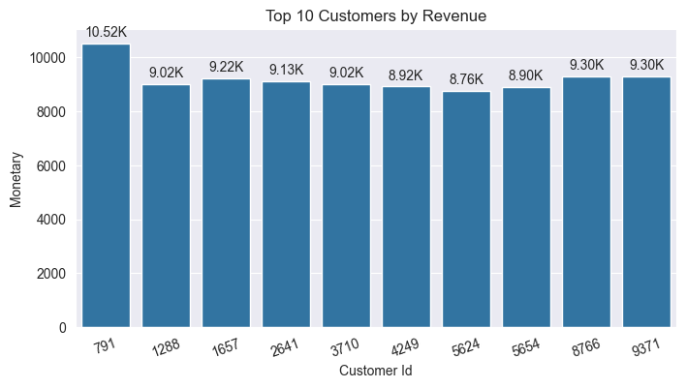
Observation
- Customer 791 is the highest revenue-generating customer, contributing approximately 10.52K in revenue.
- The remaining top customers generate between 8.76K and 9.30K in revenue.
- Revenue among the top 10 customers is relatively close, with no extreme gap between most customers.
- Several customers contribute over 9K in revenue, indicating a strong group of high-value customers.
Interpretation
The business has a group of highly valuable customers who consistently contribute significant revenue. While Customer 791 leads the ranking, the revenue distribution among the top customers is fairly balanced, reducing dependence on a single customer.
Business Impact
A relatively small number of customers contribute a substantial portion of total revenue. Retaining these customers is essential because losing even a few high-value customers could negatively impact overall business performance and profitability.
Recommendation
- Develop VIP loyalty programs for top-spending customers.
- Provide personalized offers, exclusive discounts, and premium customer support.
- Monitor purchasing behavior of top customers to identify early signs of disengagement.
- Implement retention strategies aimed at maintaining long-term relationships with high-value customers.

Top 10 Customers by Frequency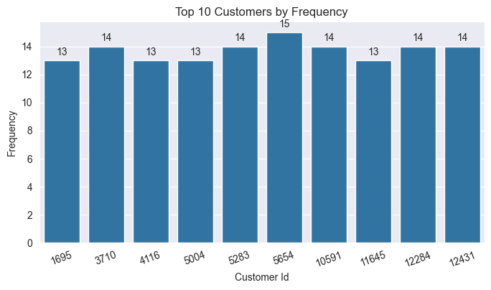
Observation
- The highest-frequency customer (Customer 5654) placed 15 orders.
- The remaining top customers placed between 13 and 14 orders.
- Purchase frequency among the top 10 customers is very consistent, with only a small difference between customers.
- No customer significantly outperforms the others in terms of order frequency.
Interpretation
The business has a group of highly engaged customers who consistently make repeat purchases. The small variation in frequency suggests that these customers exhibit similar purchasing behavior and represent a stable and loyal customer base.
Business Impact
Frequent buyers contribute recurring revenue and help improve customer retention. These customers are more likely to respond positively to loyalty programs, personalized recommendations, and membership benefits, making them valuable assets for long-term business growth.
Recommendation
- Reward high-frequency customers through loyalty and rewards programs.
- Offer exclusive promotions and early access to products for repeat buyers.
- Analyze the purchasing behavior of these customers to identify patterns that can be replicated across other customer segments.
- Encourage medium-frequency customers to increase purchase frequency through targeted marketing campaigns.

RFM Heatmap
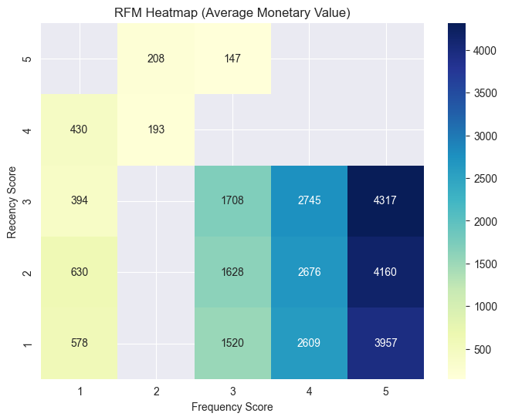
Observation
- The highest Monetary values are concentrated in customers with high Frequency Scores (4–5).
- Customers with Frequency Score 5 generate the highest average revenue, reaching approximately 3,957–4,317.
- Monetary value increases consistently as Frequency Score increases.
- Customers with Frequency Scores 1–2 contribute significantly lower revenue, generally below 700.
- The influence of Frequency on Monetary value appears stronger than the influence of Recency.
Interpretation
The heatmap reveals that customer spending is primarily driven by purchase frequency. Customers who buy more often consistently generate higher revenue regardless of their Recency score. High-frequency customers represent the most valuable customer groups and contribute disproportionately to overall business performance.
Business Impact
Frequency is the strongest driver of customer value in the dataset. Increasing customer purchase frequency can significantly improve customer lifetime value, revenue generation, and long-term profitability. Customers with low frequency scores represent an opportunity for growth if they can be encouraged to purchase more often.
Recommendation
- Focus marketing efforts on increasing customer purchase frequency.
- Implement loyalty programs, subscription models, and rewards systems to encourage repeat purchases.
- Identify customers with moderate Frequency Scores and target them with personalized campaigns to move them into higher-value segments.
- Maintain engagement with high-frequency customers through exclusive offers and retention initiatives.

Key Findings
- Potential Loyalists represent the largest customer segment.
- Loyal Customers and Champions generate a significant share of total revenue.
- Customer spending increases as purchase frequency increases.
- Recently active customers tend to generate higher revenue.
- Revenue is concentrated among a relatively small group of high-value customers.
- The Lost Customer segment is relatively small, indicating good overall retention performance.
- The business has strong opportunities to convert Potential Loyalists into Champions.

Recommendations
- Develop loyalty programs to convert Potential Loyalists into Loyal Customers and Champions.
- Implement personalized marketing campaigns for high-value customer segments.
- Create retention programs for At Risk customers to reduce churn.
- Offer exclusive rewards and benefits to Champion customers.
- Encourage repeat purchases through targeted promotions and cross-selling strategies.
- Continuously monitor customer behavior using RFM metrics.
- Use customer segmentation insights to support data-driven marketing decisions.

Conclusion
This project successfully segmented customers using the RFM framework and identified distinct customer groups based on purchasing behavior.
The analysis revealed strong relationships between customer engagement, purchasing frequency, and revenue generation. Furthermore, the segmentation highlighted opportunities for customer retention, loyalty development, and revenue growth.
The findings provide valuable insights for improving customer relationship management, increasing customer lifetime value, and supporting strategic business decision-making.

